JP STEVENS CHOIR
THANKSGIVING PIE SALE
FROM BATTLEVIEW ORCHARDS
COOKING A THANKSGIVING DINNER CAN BE EXHAUSTING!
WHY NOT HAVE A FRESH BAKED PIE MADE JUST FOR YOU?
ORDER YOUR FRESH PIE TODAY!
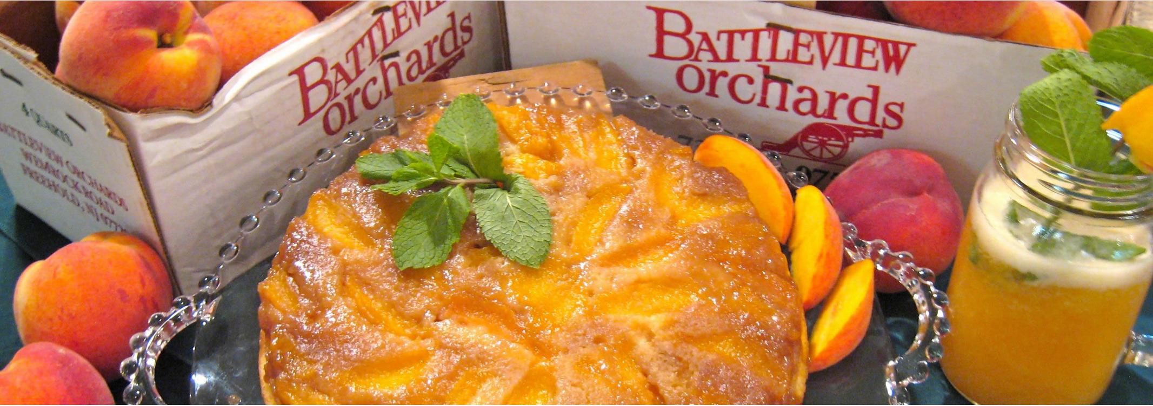
ALL PIES ARE 10” AND REFRIGERATED $16.00/pie
ALL ORDERS MUST BE RETURNED TO THE CPA BOX IN THE CHOIR ROOM NO LATER THAN NOVEMBER 15TH 2019 AT 3:00pm
PAYMENT IS DUE AT TIME OF ORDER.
ORDERS WILL NOT BE ACCEPTED WITHOUT PAYMENT
Make checks payable to “JPS CPA”
Questions ? PLEASE CALL JEFF CLEMENS @ 732-221-0721 or email jpschoirparents@gmail.com
Pies will be available for pickup in the Choir room on Tuesday, Nov. 26th from 5:00pm to 6:00pm
Any pies not picked up will be donated to a local food bank.

